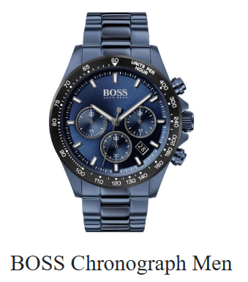

**Product Name:** Boss Chronograph Men

**Description:**  
Elegant and sporty men's chronograph watch with a black stainless steel bracelet and beige dial, ideal for both casual and formal wear.

**Specifications:**

* Movement: Quartz (VD55)
* Case Size: 45.8mm
* Dial: Beige
* Strap: Black stainless steel
* Water Resistance: 5 ATM
* Functions: Chronograph stopwatch, 3 sub-dials
* Glass: Mineral
* Clasp: Push-button deployment

**Price:** Rs. 27,000